MACH4METAL

metalworking machinery
Transito 21
6909 DA BABBERICH Netherlands
Tel. +31 (0)316-247123

Bank No : 66.52.13.883
IBAN : NL33 INGB 0665 2138 83
BIC : INGBNL2A

HACO Guillotine HSLX 3000 x 6 mm
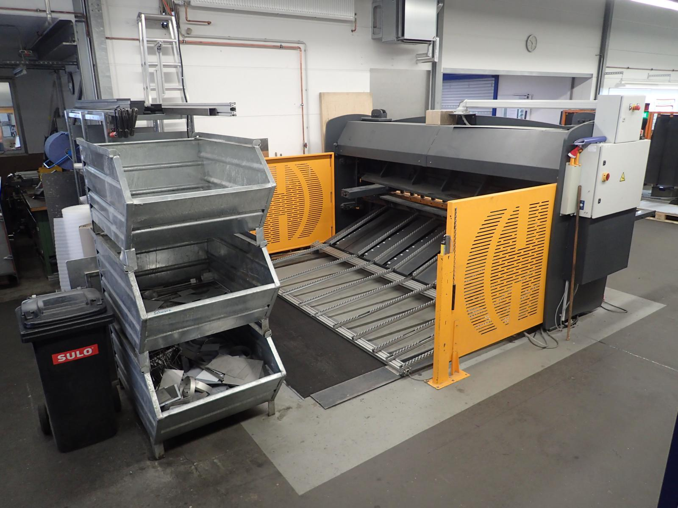

- Make : HACO Belgium
- Type : HSLX
- Serial : 22668
- YOP : 2005

- Cutting length : 3.050
- Max. steel : 6 mm
- Max. stainless : 3 mm
- Max. aluminium : 8 mm
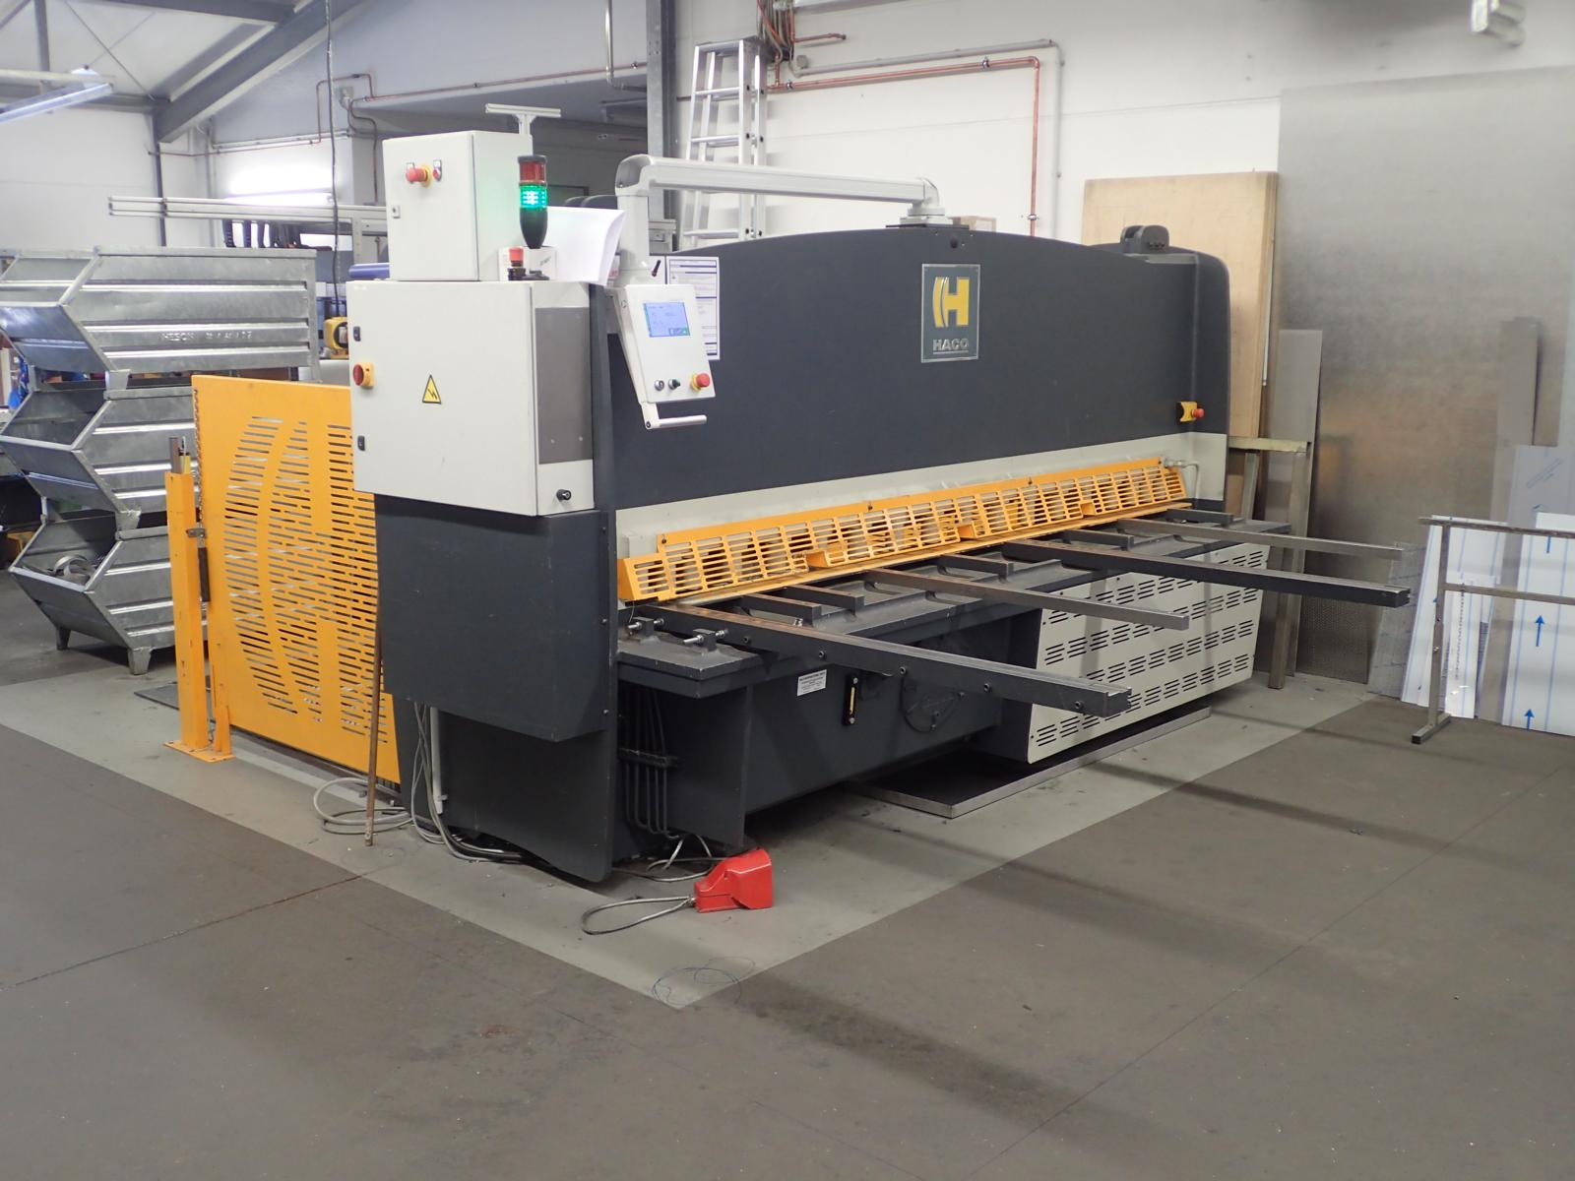
- Cutting angle : 0.5 – 3 Grad
- Stroke’s : 17 / 9
- Number off holders : 18 pieces
- Depth backgauge : 750 mm

- Incl. sheet support back side
- Incl. Cybelec CybTouch 8 backgauge
- Incl. Safety screen back side

- Dimensions
- Length : 3.400
- Width : 3.900
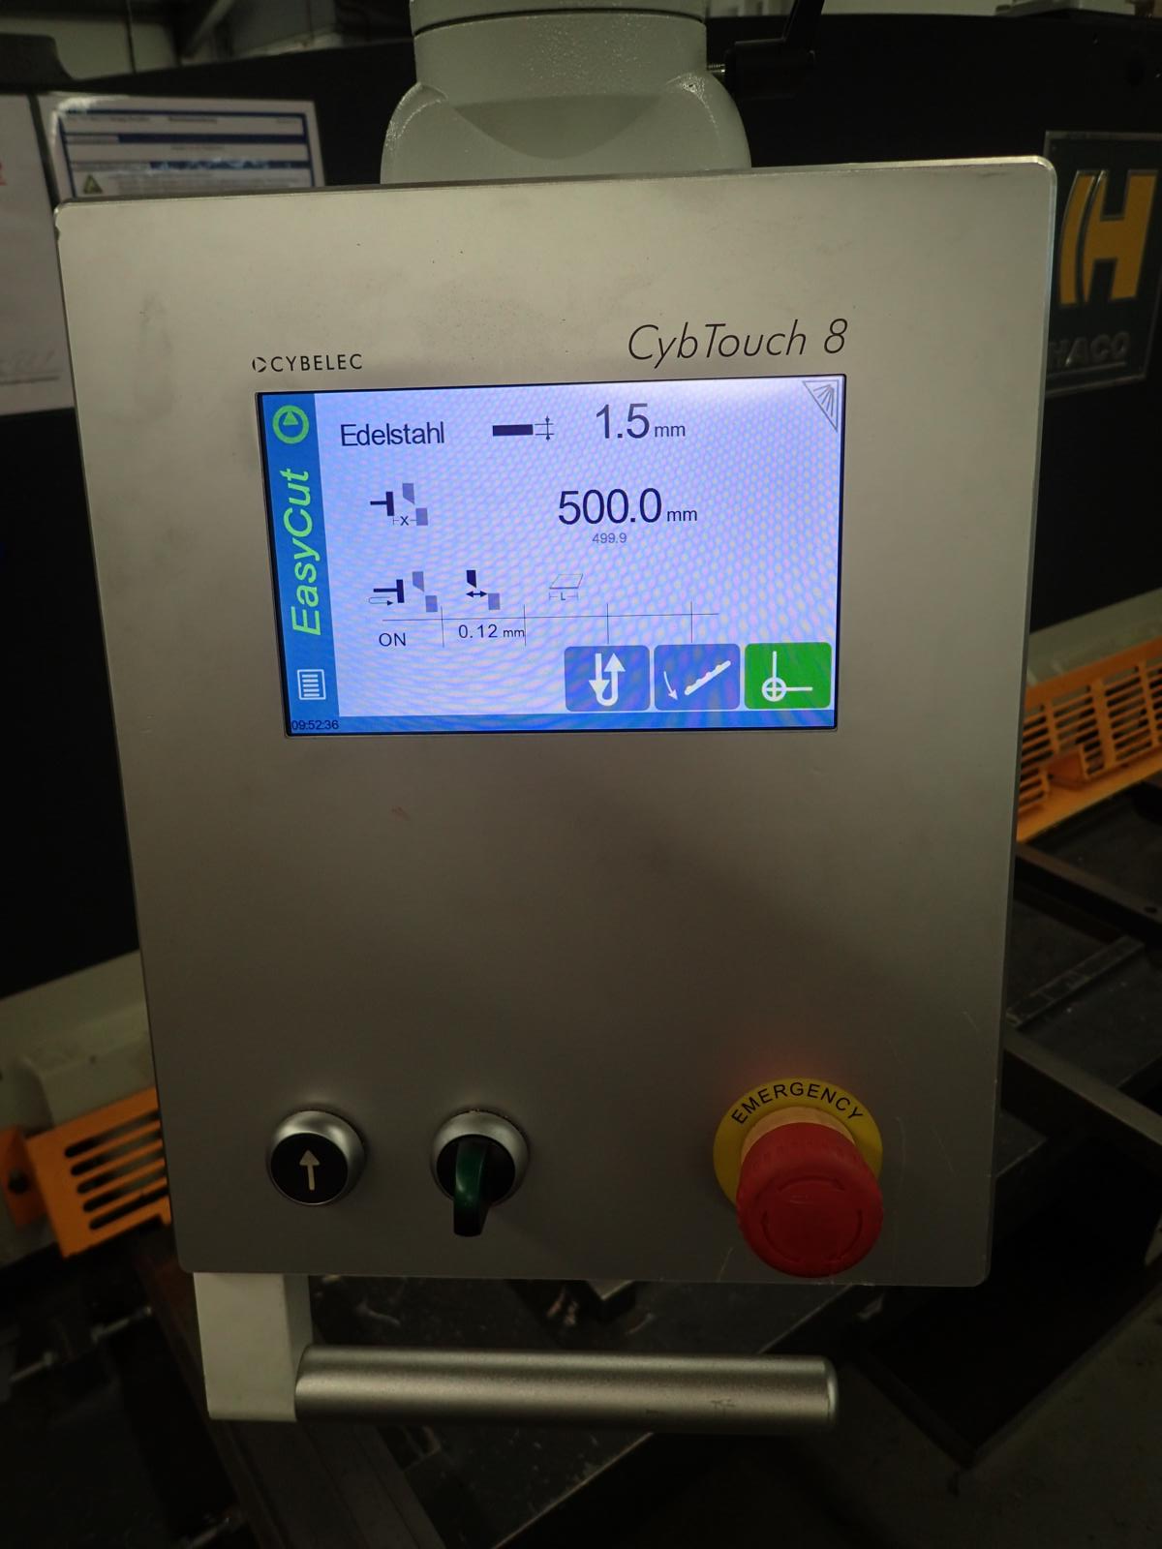
- Height : 2.100
- Weight : 6.230
- Power : 400 V / 11 kW

- Upgraded in 2016 for € 28.000
- Cybelec Touchscreen € 10.000
- Safety guide screen € 8.000
- Fast servo engines € 3.300
- Paralel backgauge € 6.700

Please Note: The above information has been obtained to the best of our ability and belief from, and from the manufacturers where possible. It is given in good faith, but its accuracy can not be guaranteed. Accordingly, it will not form a representation or constitute contractual terms. We advise you to check any vital details!

